Answers to Stat 130A Sample Midterm II Questions

1. a) k = α + 1, b) EX = (α + 1) / (α + 2), c) For 0 < x < 1, F(x) = x^{α + 1}.

2. EX^{1/2} = 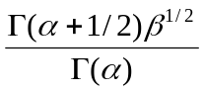.
3. 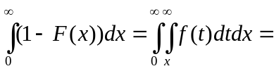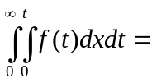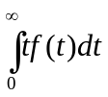 = 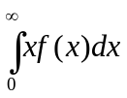 = EX.

4. a) Y ~ N(0, 200), b) X | Y = y ~ N(y/2, 50), c) Answer is evident from the answers to a) and b).

5. a) k = 3/2, b) Exe^{-Y} = 3/32.

6. a) f(y) = 1 / (1 + y)² for y > 0, b) X | Y = y ~ Γ(2, 1 / (1 + y)),
c) E(X | Y = 1/2) = 4/3.

7. f(x) = 3x² for 0 < x < 1, EX = 3/4, EX² = 3/5, V(X) = 3/80;

f(y) = 3(1 – y)² for 0 < y < 1, EY = 1/4, EY² = 1/10, V(Y) = 3/80;

EXY = 1/5, ρ_{X,Y} = [1/5 – (3/4)(1/4)] / 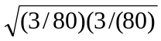 = 1/3.

